1. Change the text to “Pick the date(s)” (sometimes there will not be multiple dates)

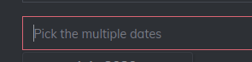

1. The date picker goes invisible because of the previous date auto selection (change the date picker visibility to top of the text box)

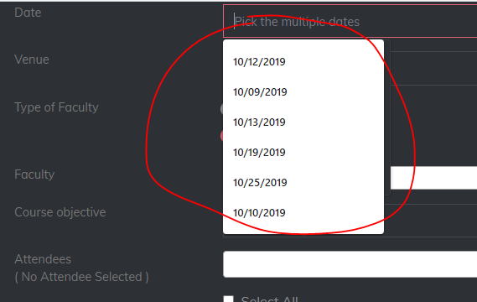

1. Prevent selecting previous dates
2. Prevent selecting Holidays

5.Inter change the radio buttons (make internal to first selection : suggestion)

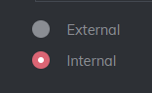

6.Alignment should be proper

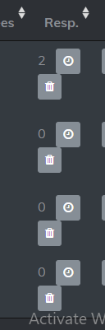

1. The default date in mark attendance section is current date,change it to the first date of meeting
2. The trainer can’t understand if he is marked an attendance for a date(s) or for an employee(s) if he again taking the attendance mark section

9.The attendance is marked for all dates,if the employee is not available for few day(s),what will do?